Beautie
Breed: Quarter Horse/Arabian
Color: Sorrel
Markings: Blaze & half pasterns on both hind & right front
Height: 14.2 hands
Age: 5 years old
Arrived at SVYR: November 30th, 2013
Rider Level: Authorized Personnel Only
In 2013 Dona and Mandy went to look at a possible new pony, for the ranch, named Silver. He was an old little pony in the pasture with a 2 year old filly, Nabiah. She had a tumor near her eye, but it didn’t affect anything. Dona decided Silver and Nabiah would be a great addition to the ranch. The new horses arrived in November of 2013. We decided to rename Nabiah, Beautie because of the resemblance to Dona’s childhood horse, Beauty, and even with the tumor near her eye she was an absolutely beautiful horse.
After we got the new horses settled in, we realized that while we thought young little Beautie would be a little trouble, it was the other way around. Silver was apparently previously abused and would shake in fear, rear and paw at you when he was being saddled. We tried to show him he could trust us but he was set that being saddled was a painful and forceful thing. We couldn’t keep Silver, so he was sold to a loving family to live as a pasture pony and only to be lovingly brushed, but never saddled. We kept Beautie for she didn’t trust anyone either, but was young and very teachable.
Zarra and Dona have been working with Beautie over the last three years, and she has been doing very well. She will soon be able to be ridden at programs and events at SVYR!
Fun Fact: Boaz and Ruth think Beautie is their mother, and Beautie thinks Casey is hers!
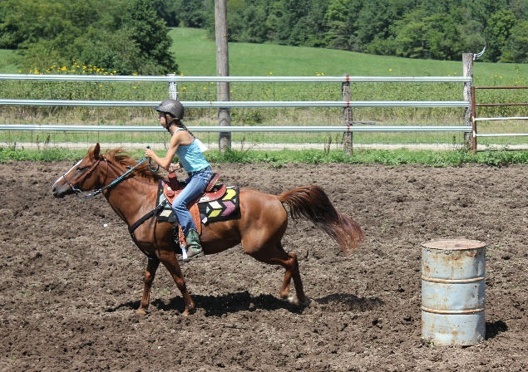
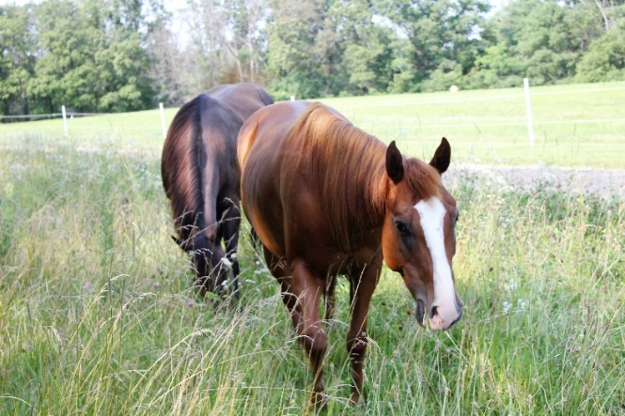

Bambi
Breed: AHA Registered Purebred Arabian
Color: Sorrel
Markings: Star & Pastern on Right Front & Hind
Height: 14.3 hands
Age: 24 years old
Arrived at SVYR: 2002
Rider Level: Beginner & Up
Bambi arrived at Son Valley Youth Ranch as an easily frightened and wild 9 year old. She was named Bambi because when she was born she looked like a fawn! Her registered name is Halimas Bambi, Only Dona could ride her because she would often spook. As she was ridden more and more she became calmer and more trusting. She even got to be ridden in Dona and Jeff’s wedding!
In 2014 Bambi got a rare disease called purpura hemorrhagic. It causes various spots on the body to swell and break open. She also lost a lot weight, which she is still gaining back. We didn’t know if she would make it because there wasn’t a specific treatment of the disease. Through wound cleanings and various applications of Bag Balm, several times a day, she slowly but surely recovered. She can’t go on as hard or long of rides that she would like too but, is still a fun horse to ride.
Bambi is now a great horse for anyone to ride and is one of the children’s favorites. She may be the oldest horse at SVYR, but her sassy attitude doesn’t show it!
Fun Fact: Bambi had 3 foals at her first home!
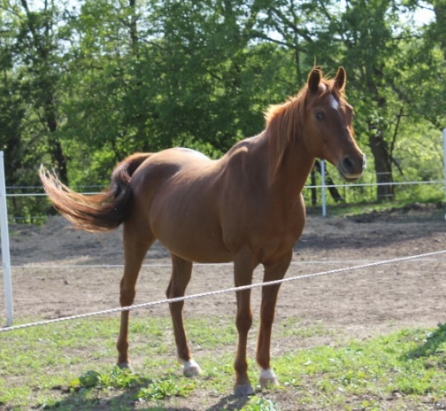
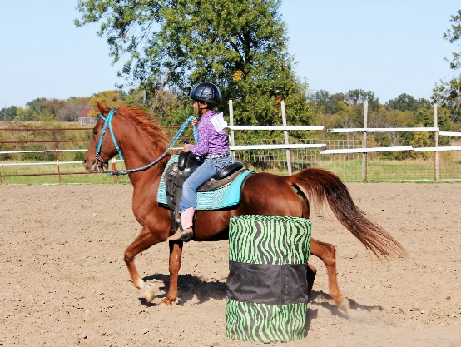
Rusty
Breed: Pony
Gender: Gelding
Color: Strawberry Roan Paint
Markings: Blaze; Four Stockings
Height: 12.1 hands
Age: 12 years old
Arrived at SVYR: April 18th 2006
Rider Level: Intermidiate & Up
Rusty came to Son Valley Youth Ranch as a birthday present for 5 year old Zarra. He was from an amish family and a tad skinny, but he was only two. The same day we got him, the onry little pony escaped! He was soon found and returned safely.
The first time Zarra rode Rusty it didn’t turn out as expected. As Dona led Rusty and Zarra around the dogs came up barking behind them and spooked Rusty. He threw Zarra off and ran around quite shook by all the noise. After he was caught Dona hopped on him and he reared straight up and threw her off too!
After a few years of consistent riding, Rusty has became a fun little pony to ride. He is also not as easily spooked now (as long as no plastic bags are near!) and enjoys being ridden. Rusty is pretty well behaved most of the time, but will always have an onry side to him. He may be the smallest, but HE thinks he is the mighty “stallion” of the herd!
Fun Fact: Rusty loves jumping and, despite his size, is the best jumper at SVYR!

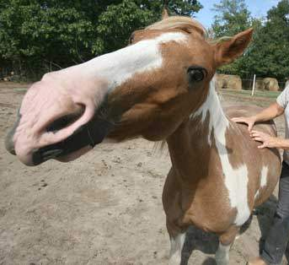
Boaz
Breed: Quarter Horse
Color: Dunalino
Markings: Stripe & Snip
Height: 14.1 hands, still growing
Age: 1.5 years old
Arrived at SVYR: November 2015
Rider Level:

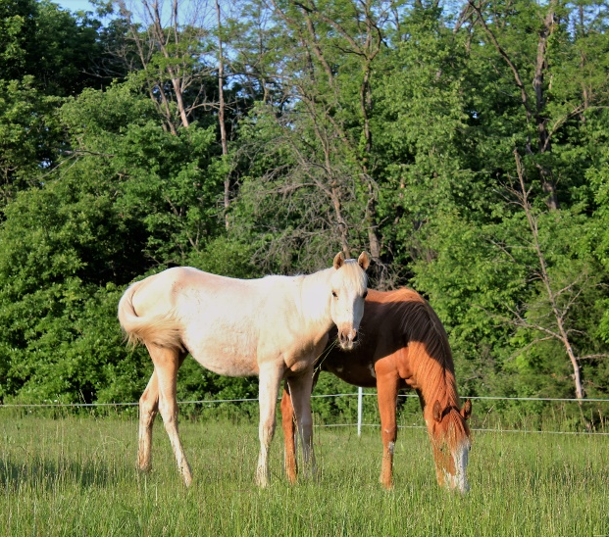
Ruth
Breed: Quarter Horse/ Paint
Color: Sorrel Paint
Markings: Bald face; Sock on hind
Height: 13.3 hands, still growing
Age: 1.5 years old
Arrived at SVYR: November 2015
Rider Level:

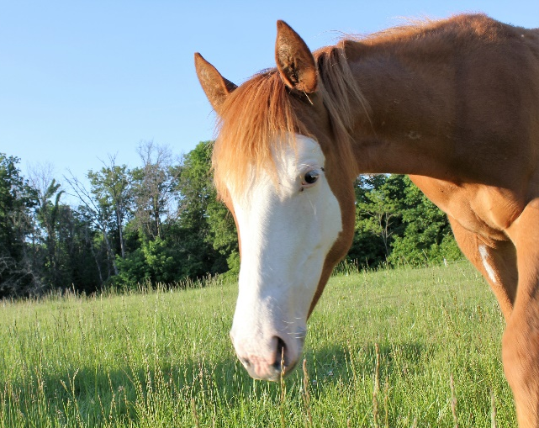
Shadow
Breed: Morgan
Color: Black
Markings: None
Height: 15.1 hands
Age: 18 years old
Arrived at SVYR: October 2010
Rider Level: Intermidiate – Advanced

Shadow arrived at SVYR in October 2010. She is a black Morgan horse. Shadow used to live with an older couple but they couldn’t ride her anymore, and she loves to ride. One day Dona was speaking at Shadow’s previous owner’s church and they came and asked Dona to take Shadow, because they thought Son Valley Youth Ranch would be a wonderful place for her to live!
Son Valley Youth Ranch has taken her and cared for her these past 6 years. Shadows favorite thing to do is to go trail riding, she loves the trails so much! Shadow also really likes to gallop, she would gallop all the time if she could. Her coat stays black in the summer, but turns to a lighter brown in the winter time. Shadow likes riding all year round but, she just gets really sweaty in the summer time. We are all so glad Shadow is in our ranch family, because she loves it here!

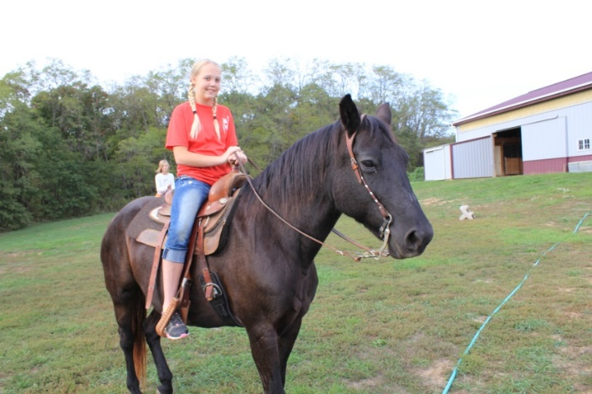
Dancer
Breed: Quarter horse mix
Color: Sorrel
Markings: Star
Height: 15 hands
Age: 20+ years old
Arrived at SVYR: June 2011
Rider Level: Experienced Beginner & Up

Dancer arrived in June of 2011. She was a true gift from god, we found her on the side of the road 1 mile from the ranch. SVYR rescued her from neglect. Dancer was in need of some true love and care. She is am now a favorite at SVYR. She is a wonderful, sweet, and smooth horse to ride. Dancer is a trustworthy and gentle horse, and loves everybody!
Dancer absolutely love to go riding through the trails. During the fall is her favorite time of year because there are less horse flies and less sweat! Dancer is a beautiful brown quarter horse and she loves grazing in the pasture with all the other horses. Son Valley Youth Ranch is proud to be Dancers owner, she is a big blessing to the ranch. She loves it here watching children Bond, Heal, and Grow!
Fun Fact: When Dancer is cold she will neigh and it will sound like an owl!
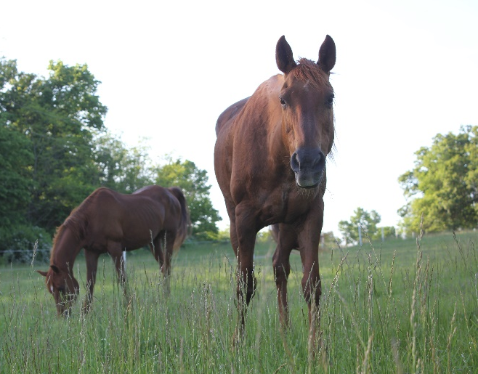
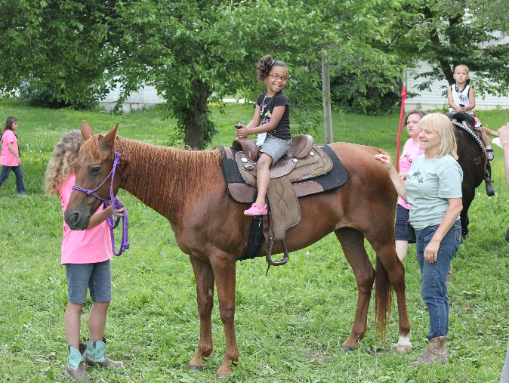

Velvet
Breed: AHA Registered Purebred Arabian
Color: Dark Bay
Markings: Blaze; pasterns
Height: 15 hands
Age: 21 years old
Arrived at SVYR: 1998
Rider Level: Beginner & Up

Velvet is Dona’s own personal horse that is used at the ranch for all levels of riders. But everyone knows Velvet prefers Dona riding her.
Velvet was injured in 2000 on her right front leg at the age of 7 years old. She had surgery and Dona was told she could never be rode. But through prayer, healing, & trying lots of things she now loves running through the trails with Dona and taking first in barrels and poles at a local fun show. She was rode by Jeff on their wedding day in October of 2003. Velvet loves to go places in the horse trailer, she hops right in can’t wait to see where we are going. She’s so much fun!

Fun Fact: Velvet loves opening up stall doors

Casey
Breed: Registered Quarter Horse
Color: Dark Brown Bay
Markings: Star
Height: 15.2 hands
Age: 17 years old
Arrived at SVYR: May 4th, 2012
Rider Level: Beginner & Up
This is Casey
Casey is very special to us. She has been at the ranch since 2012, she has her signature mark # 20. She was on her way to the sell barn, when the Amish told Dona that she needed to come and take a look before they sent her off. So as of May 4th, 2016 Casey has been here for 4 years.

When Casey first got to Son Valley she was very shy to all of the other horses and to the new people, but as she grew older and wiser she began to come out of her shell and open up to people. Casey is and always will be one of the favorites here at Son Valley because she is beautiful, caring, kind and most of all a loving and careful horse. Casey has had many ups and downs the past couple of years, but she is becoming her old self again. Casey is AMAZING at doing horse shows, going on trail rides or just plain riding in the arena with the little kids. Casey loves people! Casey is one of a kind, and she is a small part of the heart of the operation. We love her so much and hope that she brings us joy and laughs for many more years to come!
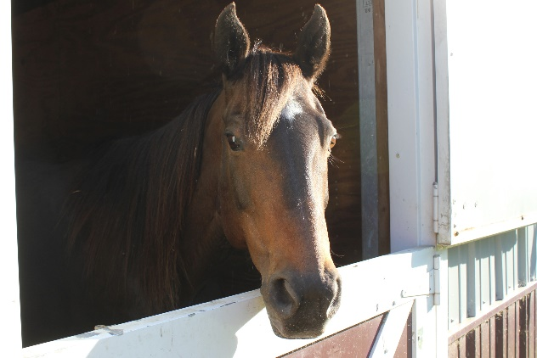
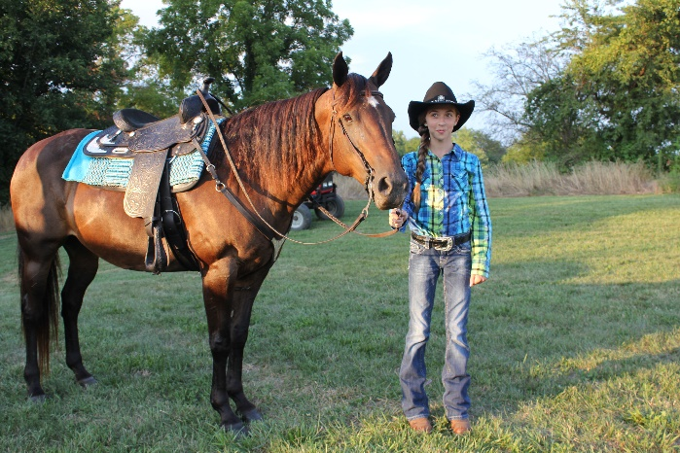

Neko
Breed: Quarter Horse Mix
Color: Sorrel
Markings: Stripe;
Height: 14.1 hands
Age: 20+ years
Arrived at SVYR: Feburary 2010
Rider Level: Beginner – Intermidiate

Neko arrived at Son Valley Youth Ranch our first year the we opened. He was used to getting his own way and would try to take Dona in barn. After working with him he turned into a sweet little guy. With beginner riders he will still take advantage if he can get away with it. Neko always lets us know if he’s sick of being in the arena. He’ll just stop or stand in the corner, but if you take him on the trails he’s ready to go again.

Prince
Breed: Registered Arabian
Color: Dapple Gray
Markings: Star
Height: 14.2 hands
Age: 4 years old
Arrived at SVYR: November 2014
Rider Level: Authorized personnel only

